INTRODUCTION:

MOTOR FAULT DETECTION SYSTEM mainly it is used to detect fault motors and also the present condition of the motor and its vibration and colling percent of the motor it is very useful in various sector like automobiles and industries. It will take main key role In automobile industries.

PROCEDURE:

We are using several types of components for this project work.

Components:

1. Audino uno
2. Vibration sensor
3. Motor drive
4. Ac motor
5. Esp8266
6. Lcd (display 16X2)
7. Jumper wires
8. 12 v adapter

Connectivity:

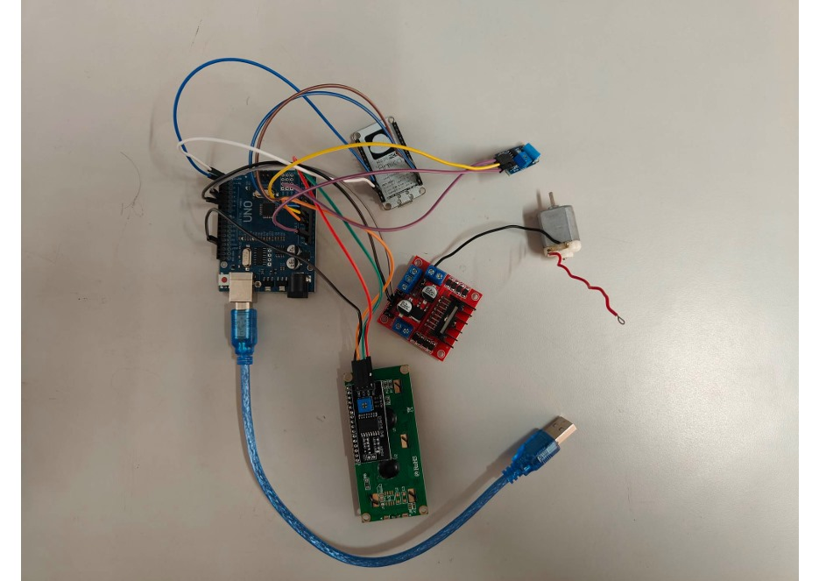

CODE OF IMPLEMENTATION:

#include <LiquidCrystal.h>

// LCD Pins: (RS, E, D4, D5, D6, D7)

LiquidCrystal lcd(7, 8, 9, 10, 11, 12);

int vibrationPin = A0; // Vibration sensor pin

int motorPin = 6; // Motor control pin (connected to transistor base)

int ledPin = 13; // LED indicator

int vibrationValue = 0;

int threshold = 600; // Adjust based on sensor sensitivity

void setup() {

pinMode(vibrationPin, INPUT);

pinMode(motorPin, OUTPUT);

pinMode(ledPin, OUTPUT);

lcd.begin(16, 2);

Serial.begin(115200);

lcd.print("Motor System");

delay(2000);

lcd.clear();

}

void loop() {

vibrationValue = analogRead(vibrationPin);

Serial.print("Vibration: ");

Serial.println(vibrationValue);

lcd.setCursor(0, 0);

lcd.print("Vib: ");

lcd.print(vibrationValue);

if (vibrationValue > threshold) { // Fault detected

lcd.setCursor(0, 1);

lcd.print("Fault Detected! ");

digitalWrite(ledPin, HIGH); // LED ON

digitalWrite(motorPin, LOW); // Stop motor

} else { // Motor runs normally

lcd.setCursor(0, 1);

lcd.print("Motor Normal ");

digitalWrite(ledPin, LOW);

digitalWrite(motorPin, HIGH); // Run motor

}

delay(500);

}

CONCLUSION:

Has till now we are completed the hardware model now we are working on the coding part so as soon as possible we are able to finish it as soon as possible

TEAM MEMBERS:

HIMABALA - CB.SC.U4AIE24028

NIKHIL - CB.SC.U4AIE24063

SANDEEP - CB.SC.U4AIE24047

CHAITHANYA - CB.SC.U4AIE24040